**IOT BASED MULTI AGRICULTURAL MACHINE**

**ABSTRACT**

India is an agriculture based country in which, 70% of people depends on the outcome of farming. But if we observe that with increase in population the farm gets distributed among the family and because of this, farmer in India held averagely only two acre farm. Also economically, farmers are very poor due to which they are unable to purchase tractors and other costly equipment hence they use traditional method of farming. Basically, many farmers in India also use bullocks, horses and he-buffalo for farming operation. This will not satisfy need of energy requirement of the farming as compared to other countries in the world. So we are thinking that human and animal efforts can be replaced by some advance mechanization which will be suitable for small scale farmer from economical and effort point of view. So we are developing this equipment which will satisfy all this need and to solve labour problem. In this equipment we used ploughing rod, seed sower, spraying and land levelling attachment. This machine performs the operation (ploughing, sowing, and spraying) which is used for small scale farming. As an added advantage this machine is operated with the help of electric drive which is controlled from an internet through internet of things (IOT) concept. By using above attachments one may perform various farming operations in less time and cost with reduced man power resource.

**INTRODUCTION**

Agriculture has been the backbone of the Indian economy and it will continue to remain so for a long time. It has to support almost 17 percent of world population from 2.3 percent of world geographical area and 4.2 percent of world’s water resources. The present cropping intensity of 137 percent has registered an increase of only 26 percent since 1950-51. The net sown area is 142 Million hectare. The basic objective of sowing operation is to put the seed and fertilizer in rows at desired depth and spacing, cover the seeds with soil and provide proper compaction over the seed. The recommended row to row spacing, seed rate, seed to seed spacing and depth of seed placement vary from crop to crop and for different agricultural and climatic conditions to achieve optimum yields and an efficient sowing machine should attempt to fulfil these requirements. In addition, saving in cost of operation time, labour and energy are other advantages to be derived from use of improved machinery for such operations. A traditional method of seed sowing has many disadvantages. This paper is about performing different agricultural operations with the help of single vehicle setup which can perform simultaneous operations.

**CONSTRUCTION**

The base frame for mounting overall setup is fabricated with the help of square tubes and channels with the help of metal cutting and metal joining process called welding. Wheels are mounted to the frame for its displacement, in which two at front and other two at rear axle. The steering links are attached at the front end portion and this links are connected to the drive for performing wheel steering operation. The ploughing rod attachment is mounted at the front end portion of the frame by contacting the ploughing rod to the ground surface. The seed sprinkling attachment which has the loading hopper for housing the seeds to be dipped and it gets sprinkled by metring plate which is powered by means of electric drive is mounted on the base frame with the help of bearing supported ends. The shaft which houses seed sprinkler arrangement has a sprocket which is connected to the crank wheel placed at the rear axle with the help of chain drive to move the vehicle automatically. The levelling lever is placed at the rear end portion for closing the ploughed surface. The reservoir which stores the water is placed on the chassis has a DC pump whose outlet is connected to the nozzle and allowed to spray the water to the field. All the DC drives are connected to the output pins of controller, while its input pin is connected to IOT module. The web page for controlling entire setup is created with required keys to operate agricultural machine through an internet.

**WORKING PRINCIPLE**

When the operator logged in the web page of seed sowing setup with respective web link and the power supply for activating entire module is turned on through manual interaction. Once the operator activates the key to rotate the drive, it causes the vehicle to move on the field through the rotation experienced by the drive. By activating the steering drive, turning operation is performed. Initially the ploughing rods get contacted with the ground surface according to the ploughing depth, soil ploughing operation is performed. The rotation of DC motor also makes the metering plate to rotate about its fixed axis and causes the seeds loaded inside the hopper to discharge on the fields. The water spraying operation is performed by the activation of DC pump which sucks the water from the reservoir and discharge with high pressure on to the field. At last with the help of levelling lever ploughed land gets levelled which also helps in covering the dipped seeds by the sand for proper growth maintenance.

**LAYOUT**

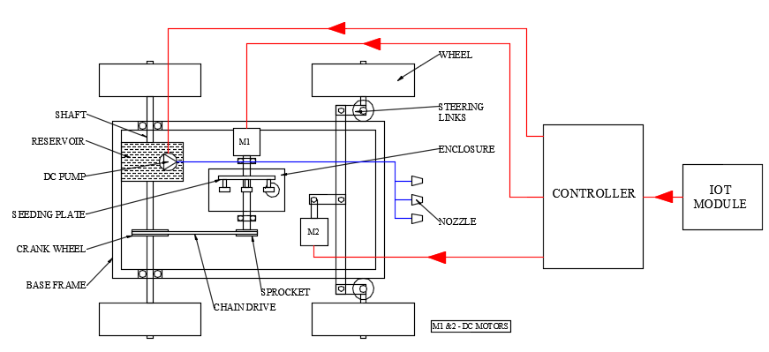

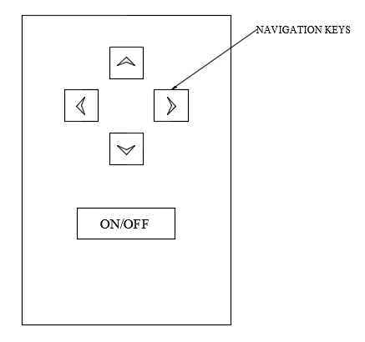

**WEB PAGE**

**ADVANTAGES**

* Usage of external drives reduces the human effort.
* Pollution free handling which is also helpful for crops.
* Instead of water liquid fertilizers can be sprayed.
* Reduces labour charges and time consumption.
* The maintenance and fabrication cost is cheap.
* Less skilled operator can also handle this equipment.

**APPLICATIONS**

* By varying the size of an equipment, it can be used in large and small fields.